

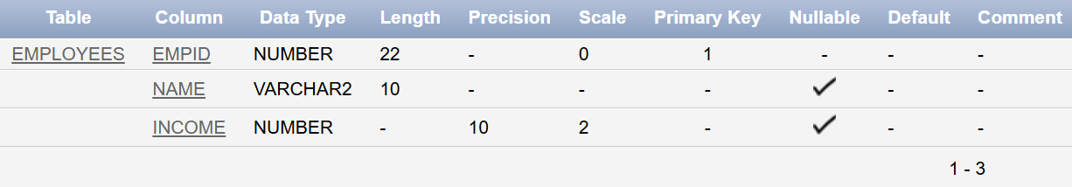



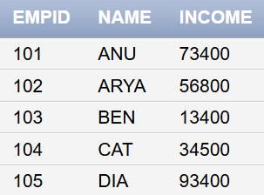

Display employee name and the annual tax to be payed by each employee. Give the name ‘Annual tax’ to the derived column Tax calculation: 30% of Annual income

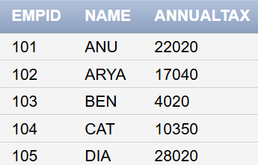

Retrieve the details of all employees sorted in the alphabetical order of their name

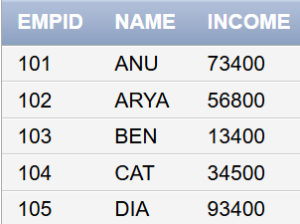

Display the details of the employee in the descending order of the income.



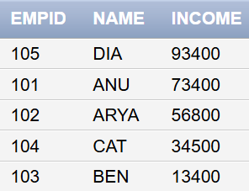

Display the details of all employees whose name starts with ‘A’ has ‘e’ in it and ends with ‘t’



Display the details of all employees who joined after ’01-Jan-98’ and whose salary is higher than 25000

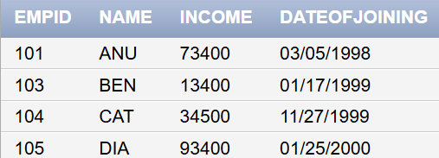

Display the details of employees who do not have a commission



Display the details of all the products as “ABC costs 52.00 after discount”. The details should come under the heading “Festival offer”

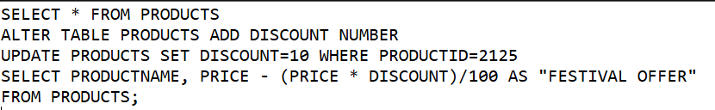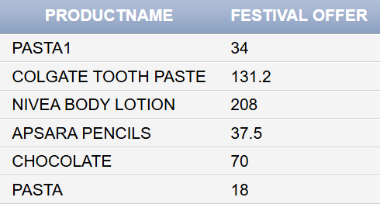

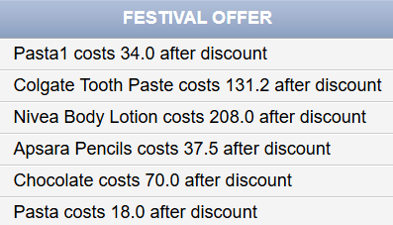

Display the details of all products within the price range 50 and 100. Do not include the products that cost 50 and 100

Redo the earlier report including the products that cost 50 and 100

Display the list of designations from the employee table without showing the duplicate values